**WEB501 Blogs**

**1)INITIAL INDEX BUILD**

In my ,website there will be 8 pages such as Home, Accommodation, Dining, Conference,Golf,Facility,Packages and Gallery. I will be using bootstrap and Following is the initial framework I have done. I am using Web Expressions to develop the site.

* I created html files for all the Eight pages
* Created a css file to accomodate future changes to page layout if neccesary (site.css )
* Created a images folder
* Downloaded bootstrap files and folders and copied them to the site folder.

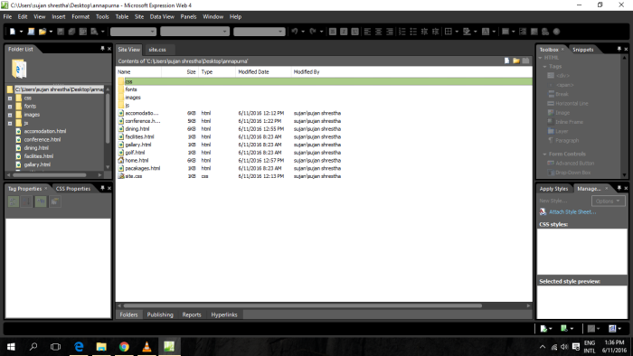

Further before start the coding i arrange  all the HTML files in order to work with bootstrap. Following shows the basic setup of the HTML files .

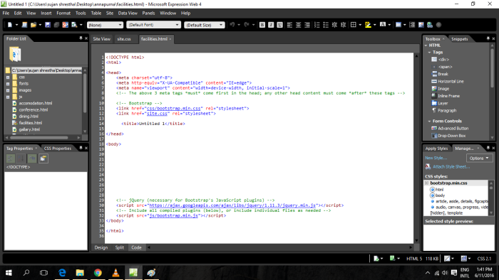

**2. INFORMATION/CONTENT DECISIONS FOR CLASSES AND IDS**

After doing first step , I move forward,I used appropriate fonts and images as per my web brief document. I would use classes and ID name according to the page lay out which I need to create.

Following are the classes that I am using: –

* logo
* image
* footor

Following are the IDs that i am currently using :-

* box1

I may use some more classes and ID s if its needed in future to customize the page.

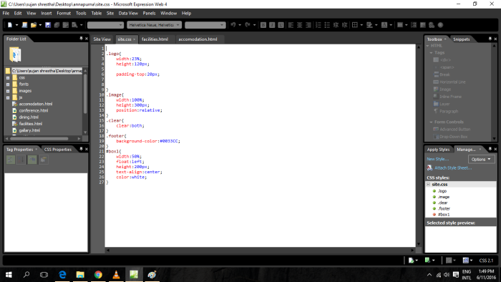

# 3) CREATING INDIVIDUAL PAGES

**Home** (Home.html)

I used home.html  HTML page for creating Home page.

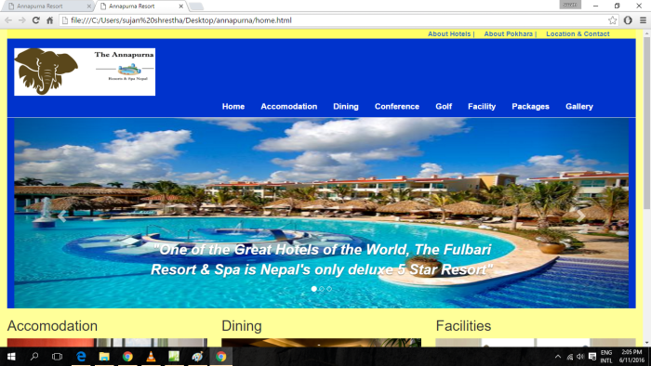

I used some of the tages for creating website.Which are follows:-

* Carousel ( Slider still not have images)
* I used <a href >links instead of Nav bars and footer.
* And i plyed with Div tags.

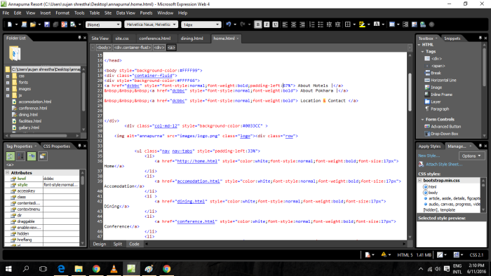

Accommodation (accomodation.html)

Here also, i played with div instaed of nav bars and footers. Also, i used View details hyperlink to read further at the bottom of description. I will communicate the images to that futher pages also.

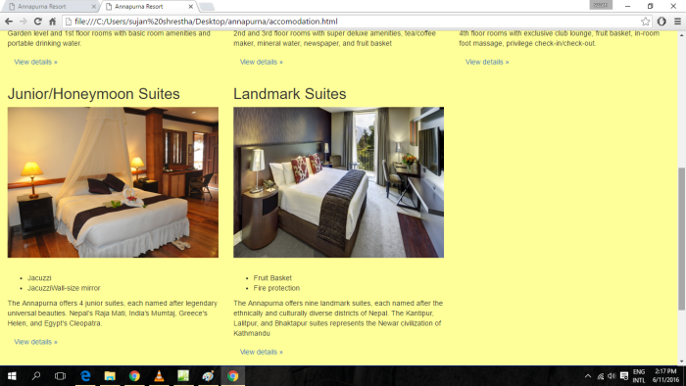

Dining (Dining.html)

For all pages, I used same coding and also i used view details link same as for the accommodation pages.

Conference (conference.html)

same as the others accommodation and dining pages.

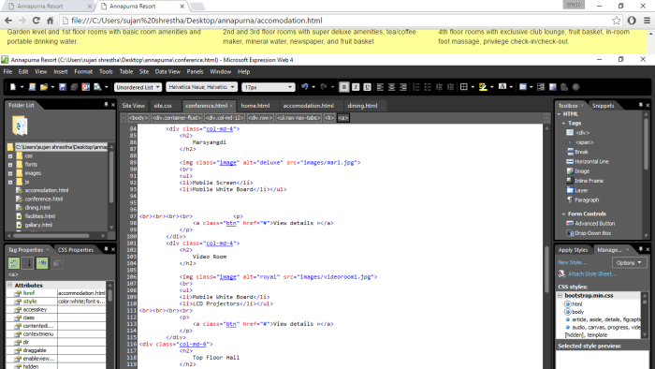

Rest of others p[ages, I am still working on them and i need to do lot of coding for view detail links also .

#### Issues I found but still stuck

I still stuck at the bottom of page . I am trying to fix the problem that i created. I tried alot but i wasnt fiex that problem . The yellow line come under the first div od City Office Div.

But when i took screen shot of that page . It didnt show in paint .

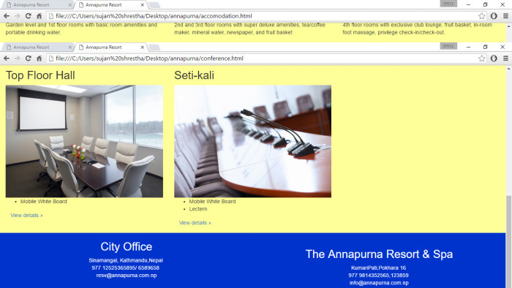

# 4) NAVIGATION

Instead of navigation bar . I used navs under component tool.

I developed the navigation bar using the layoutit.com lay out generator. I redesigned the navigationg.

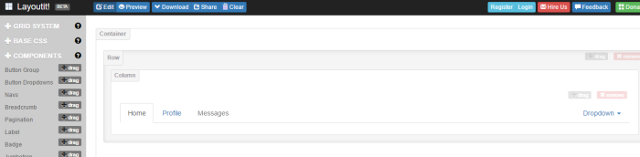

I have linked all the pages in the navigation bar. I colored formatting for the navigation bar .and i added logo of the Annapurna rresorts and spa.

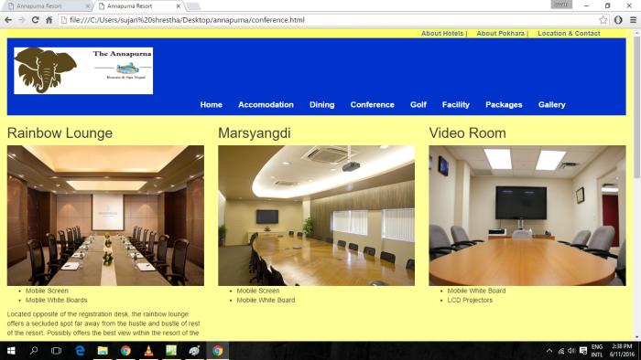

# 5) HOSTING

I have uploaded  the website for testing now. The link for my website is as follows:

<http://rudrarana.altervista.org/conference.html>

I chose altervista to host my website.

After uploading the files I checked and all the functions that I have embedded so far is working fine.

# 6.ANY OTHER INFORMATION

I am still working with my website. I need to choose more color theory and it is quite interesting  subject . I am playing with my website which is more fun and more excited .